BYTEWISE FELLOWSHIP PROGRAM

DATA ENGINEERING

Tehreem Fatima

**WEEK 2**

**23– March -2023**

***Task No 7***

**Practice following DML commands in SSMS:**

**1 - INSERT:**

**• Identity**

**• Creating a table from another table**

**• Inserting rows from one table to another**

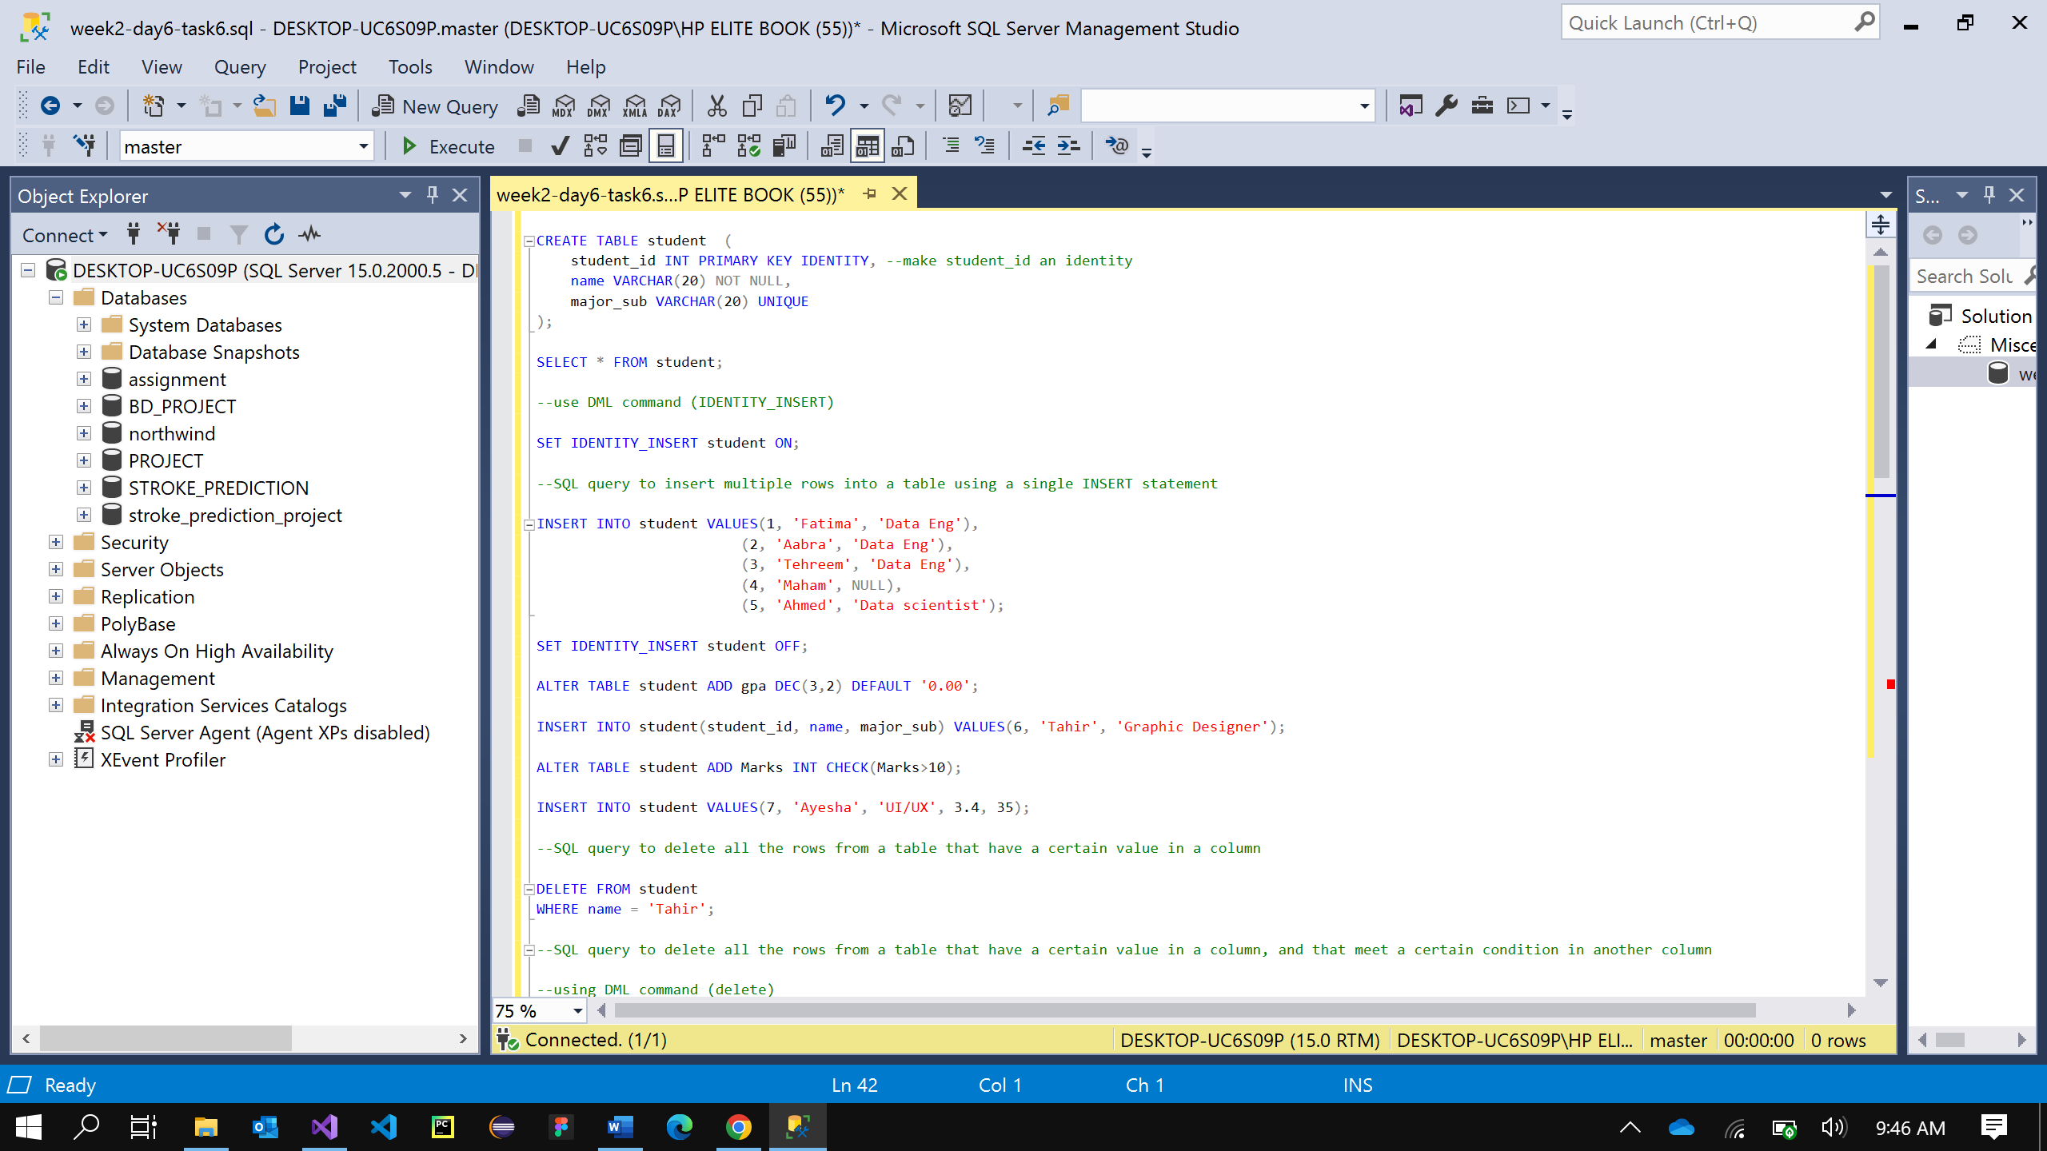

***2 - UPDATE***

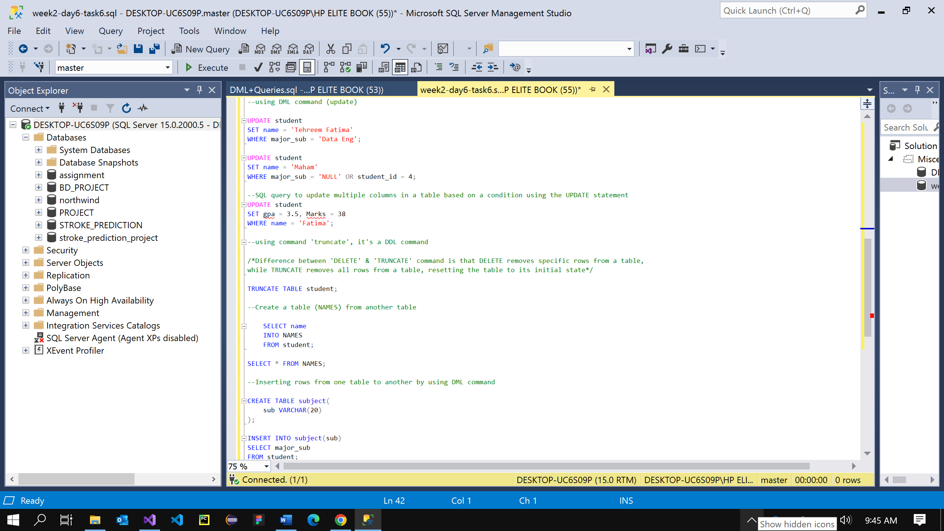

***3 - DELETE:***

***• Truncate***

***• Difference between delete & truncate***

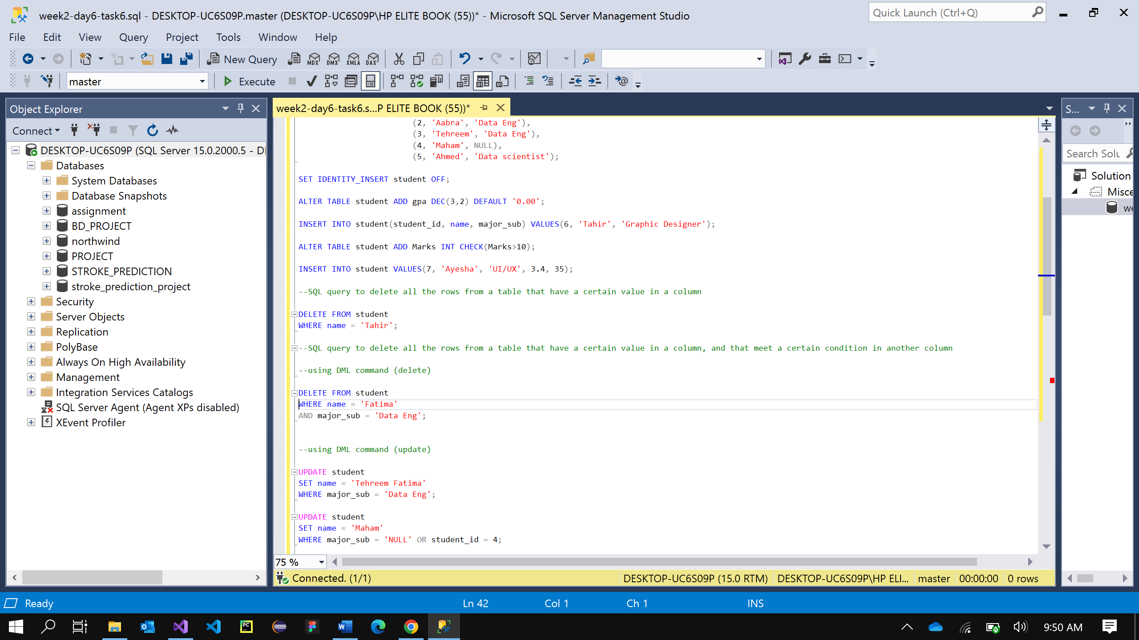

***Task No 7***

***Write the following queries:***

***1 - Write an SQL query to insert multiple rows into a table using a single INSERT statement.***



***2 - Write an SQL query to delete all the rows from a table that have a certain value in a column.***

***3 - Write an SQL query to delete all the rows from a table that have a certain value in a column, and that meet a certain condition in another column.***

**

***4 - Write an SQL query to update multiple columns in a table based on a condition using the UPDATE statement.***

